**Windows 10 Installation Guide**

**Installing Visual Studio Code**

Visual Studio Code (aka VS Code ) is “a lightweight but powerful” source code text editor with a few IDE (Integrated Development Environment) features, such as Intellisense and Live Share.

1) Go to <https://code.visualstudio.com/Download>and click on the purple rectangular button with the Windows option. You should get an option to save an executable file (.exe).

2) Click on the executable to start the installation process. Accept all defaults during installation.

3) Launch Visual Studio Code

Installing Git

Git is a free and open source distributed version control system. It allows you to track changes in files that you work on both locally on your computer and remotely in the cloud.

1.) You will install Git Bash. This will become the terminal through which you run commands, interact with your programs and files, etc. It also has the benefit of handling git installation on your Windows machine. Download it here: <https://www.git-scm.com/download/win>

Follow through with the installation instructions. You should be able to just click next through all of the instructions.

2.) Click on the executable (.exe) that you downloaded. Keep clicking ‘Next’, but make changes to the defaults as indicated below.

a.) Information (GNU general public license) - use default -> Next

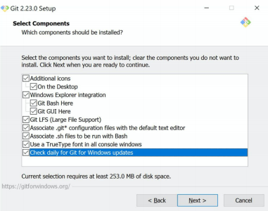b.) Select Destination Location - use default -> Next c.) Select components - check all boxes -> Next

d.) Select Start Menu Folder - use default -> Next

e.) Choosing the default text editor used by Git - choose Visual Studio Code -> Next

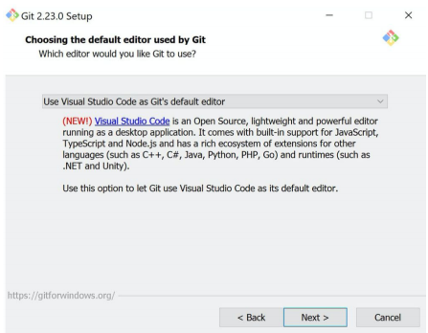Selecting the default text editor used by Git (choose Visual Studio Code)

f.) Adjusting your Path environment - use default -> Next

g.) Choosing https transport backend - use default -> Next

h.) Configuring the line ending conversions - use default -> Next

i.) Configuring terminal emulator to use with Git Bash - use default -> Next

j.) Configuring extra options - use default -> Next

k.) Configuring experimental options - use default (don’ tenable) -> Next l.) Finally, click Install!

**Installing the Anaconda distribution of Python**

Anaconda is a freemium open source distribution of the Python programming language for large-scale data processing, predictive analytics, and scientific computing. It also simplifies package management and deployment.

You’ll be installing Python 3 (3.7 as of the writing of this guide).

1. If you have an existing version of Anaconda that you’d like to get rid of first, in the Control Panel, choose “Add or Remove Programs” or “Uninstall a program” and then select “Python 2.7 (Anaconda)” or your version of Python. If you have some other version of Python you’d like to uninstall, Google it and follow the directions.

2. Go to <https://www.anaconda.com/products/individual#download> and select the Python 3.7 (as of this writing) 64 bit installer (assuming you have a 64 bit machine). If you don’t know if you have a 32 or 64 bit processor, there are ways to check this from the Control Panel or System Tools in Windows. Google it.

3. In the menus that follow:

a. Accept the User License agreement

b. install for “Just me”

c. Accept the default installation location

d. In “Advanced options”, select the option to add Anaconda to your path environment variables.

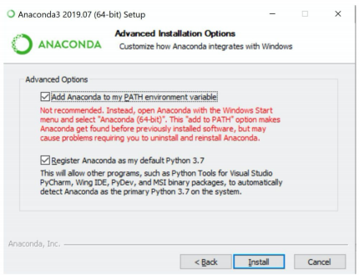e. Add Anaconda to your Path Variable (despite the warning red text, see below):

f. Select Install.

g. Keep going forward through the dialogue boxes.

h. You don’t need to sign up for Anaconda cloud or support.

i. Click Finish

**Start Up Instructions**

1) Save a copy of the Monte Carlo Template (Saved to Kristine’s Temp File) to wherever is most appropriate.

2) Go into the BUDGETOF folder, right click, and select Git Bash Here (Note: you can Git Bash into a different folder but note that you will only be able to view jupyter notebook documents within that folder and you may want to access the examples saved to Kristine’s temp files.)

3) Once the Git terminal has fished loading a new line with a $ (or maybe some other marker depending on your version) will appear) type “jupyter notebook” and press enter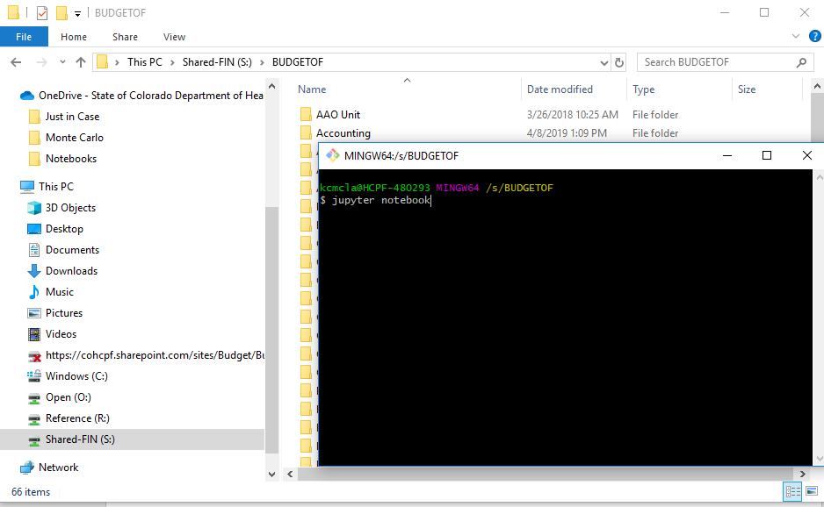

4) Jupyter Notebook should open and you can navigate to your copy of the template and start editing. (The document will have instructions from here)